|  |  |
| --- | --- |
| Payload analysis@Eaton |  |
| QXtend |

1/16/2017

Regoti, Sujata

@Eaton

QXtend

1. From payload get end point

<qcom:propertyName>**EndpointURI**</qcom:propertyName>

<qcom:propertyValue> **http://heuqa.tcc.etn.com:8081/heu1qxi163/services/QdocWebService** </qcom:propertyValue>

In the above endpoint URI, nhaqx**i**163 represents nha QXtend Inbound. For outbound : nhaqxo163

Use Link : http://heuqa.tcc.etn.com:8081/heu1qxi163

1. Get wsaTo Property

<ns2:propertyName>wsaTo</ns2:propertyName>

<ns2:propertyValue> **urn:services-qad-com:QXIheu1mfg** </ns2:propertyValue>

Here outbound receiver QXIheu1mfg.

1. Open above URI. Go to Configuration->Receivers->Outbound

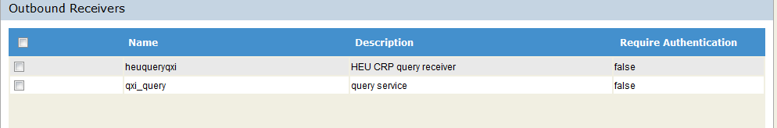

Under receivers find above receiver name.

Here QXIheu1mfg doesn’t exist. So we get warning.

1. In given payload , we can find

<ns1:result>warning</ns1:result>

And exact warning as

<ns2:tt_msg_datetime>2017-01-13T07:46:13+0000</ns2:tt_msg_datetime>

<ns2:tt_msg_desc>**WARNING: Location Master does not exist**.</ns2:tt_msg_desc>

Regoti, Sujata

WCE, Sangli

Intern@Eaton